**COMPUTER NETWORKS PRACTICALS**

Name: S.Bhavadharani

Reg.No.: 192125020

Department: B.Tech AI and ML

Course code : CSA0730

Course name: computer networks for

media gateway control

protocol

Faculty Name: Dr.R. Thandaiah Prabhu

**EXPERIMENT 1: Configuration of Network Devices using Packet Tracer (Hub, Switch, Ethernet, Broadcast)**

**HUB**

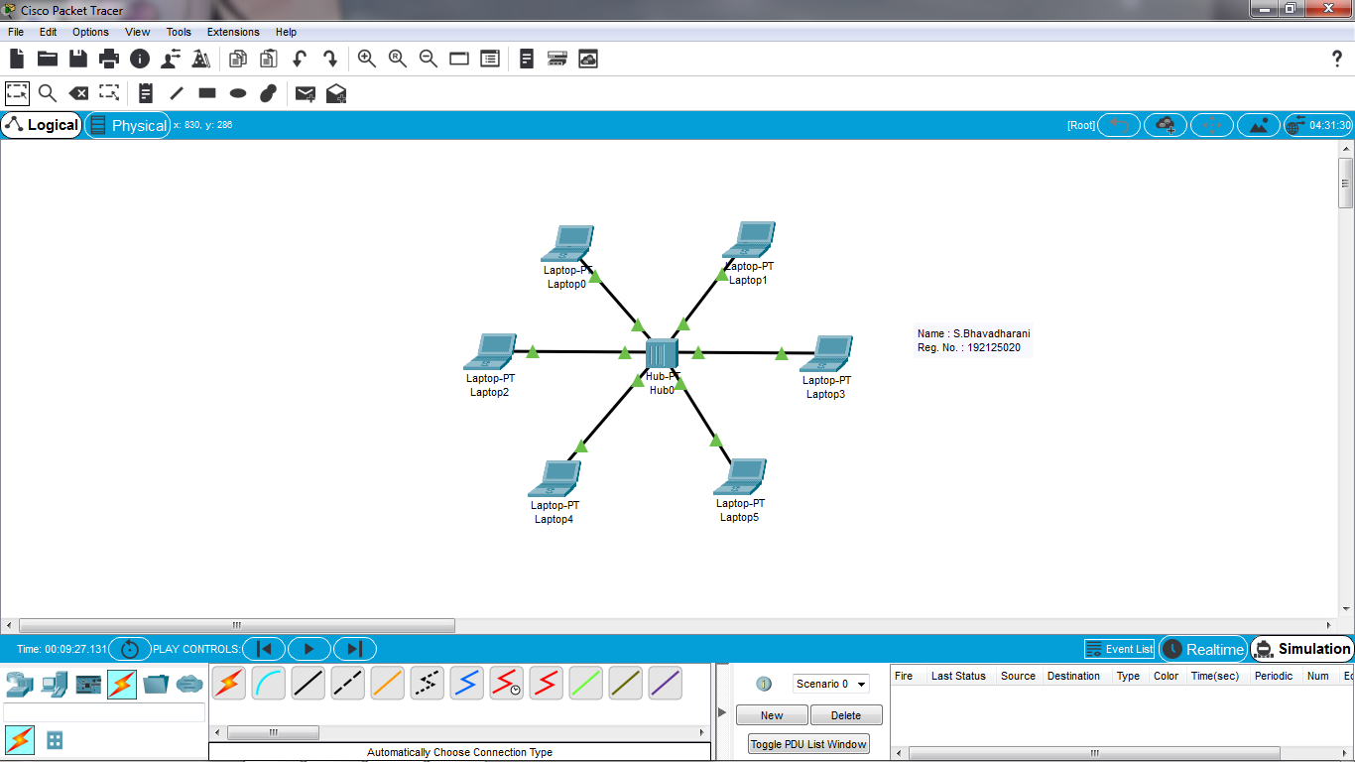

**ETHERNET**

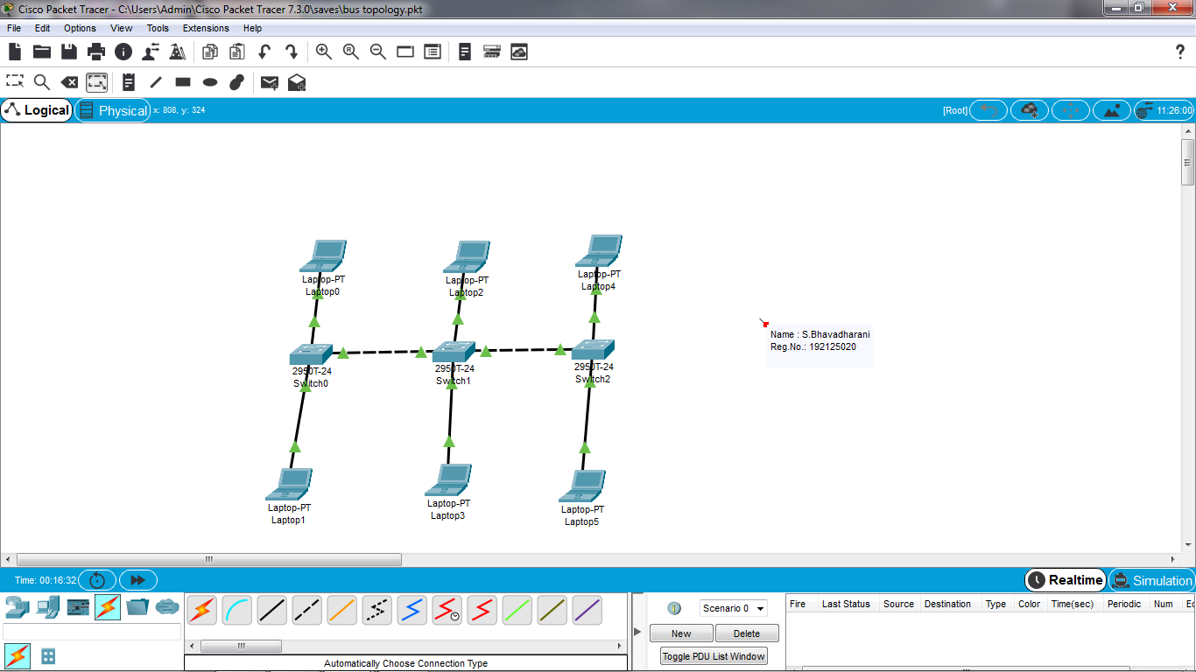

**EXPERIMENT 2: Configuration of Topologies using Packet Tracer (Star, Mesh, Tree,)**

**STAR TOPOLOGY:**

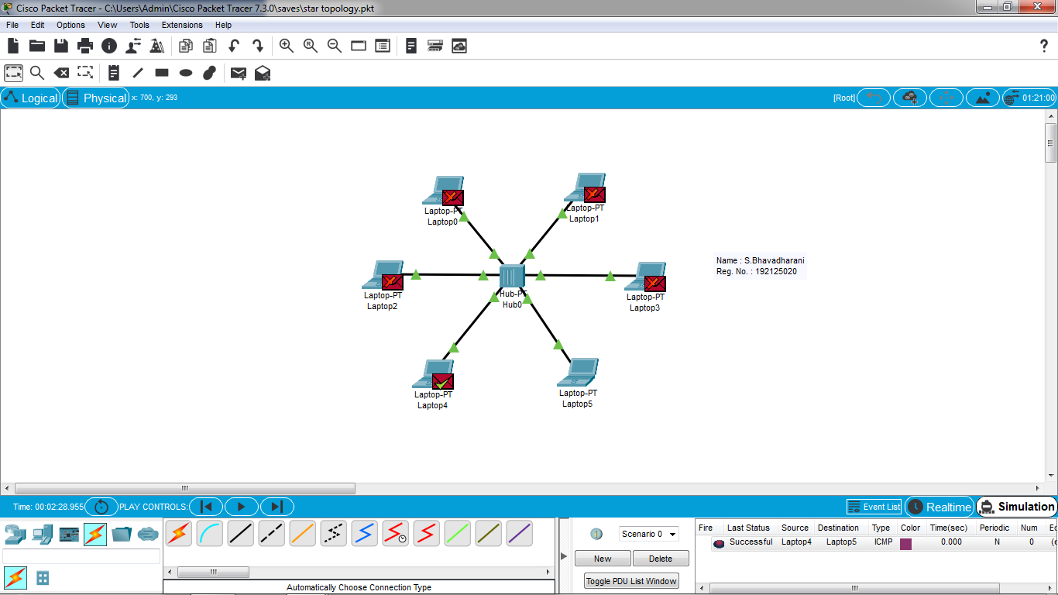

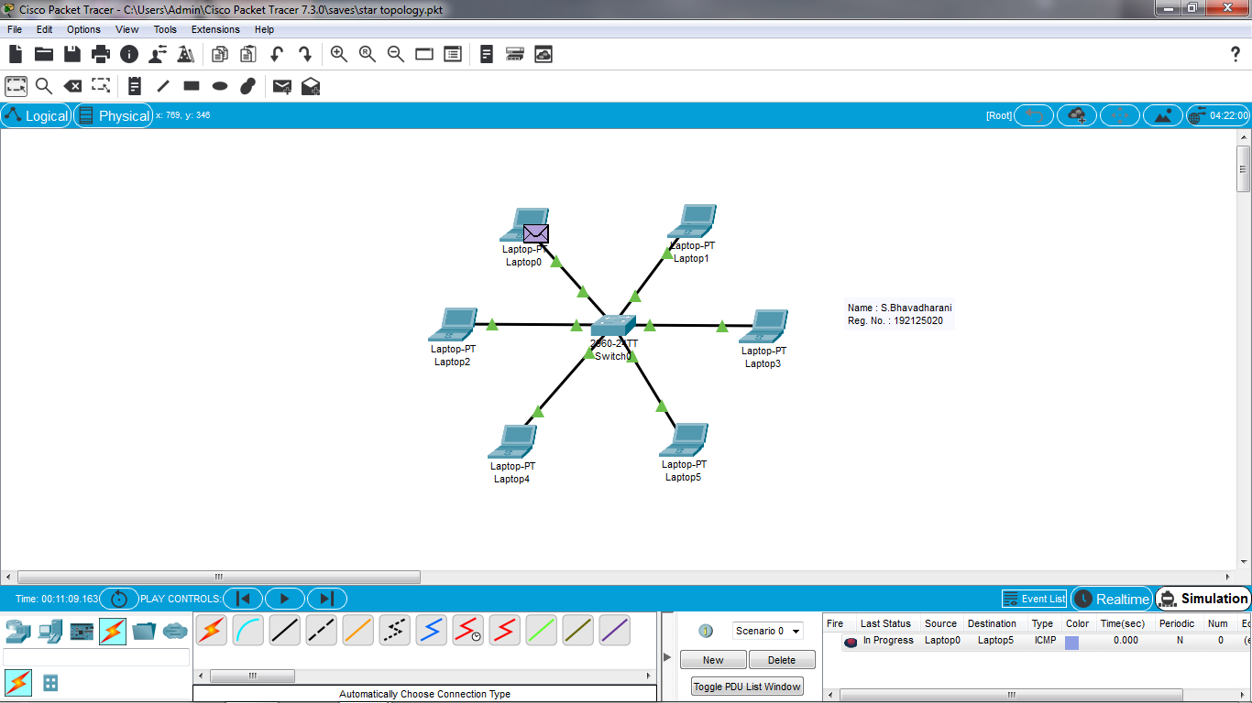

**MESH TOPOLOGY:**

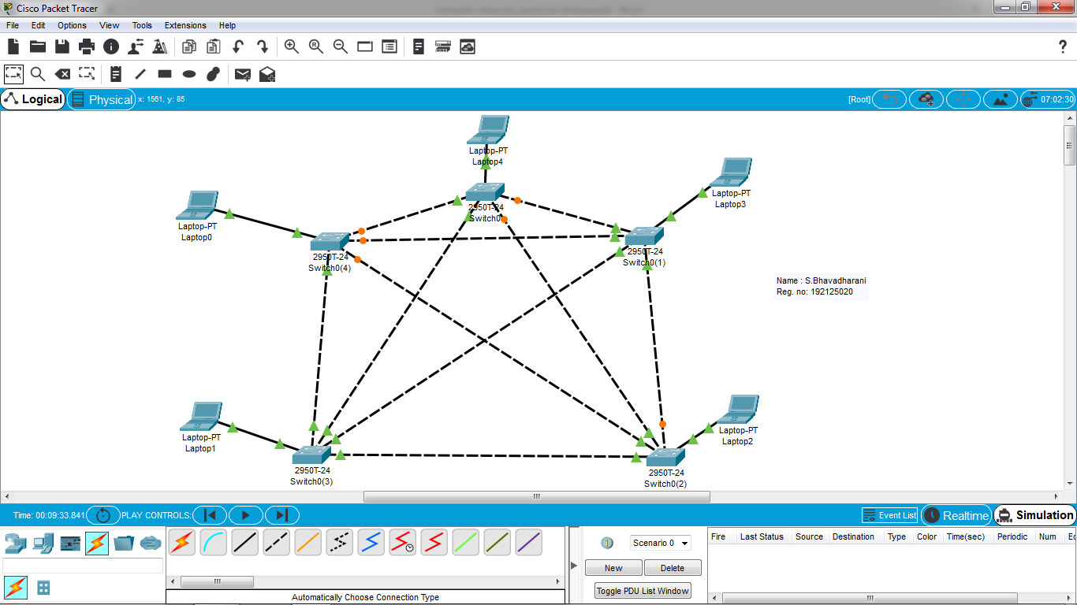

**TREE TOPOLOGY:**

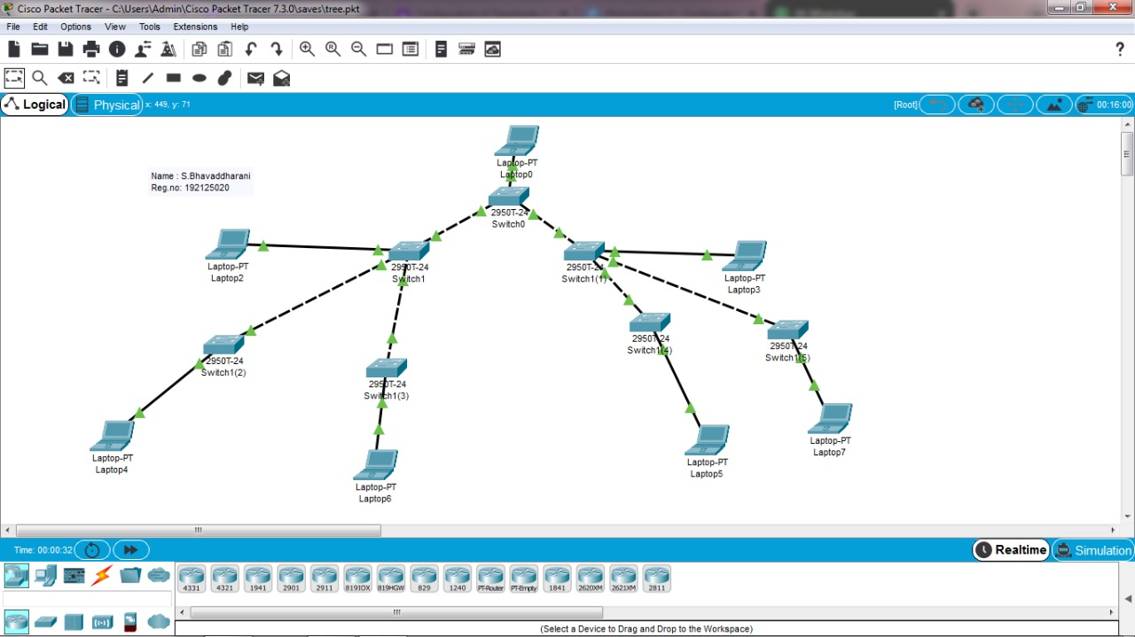

**EXPERIMENT 3: Configuration of Topologies using Packet Tracer (Bus, Ring, Hybrid)**

**BUS TOPOLOGY:**



**RING TOPOLOGY:**

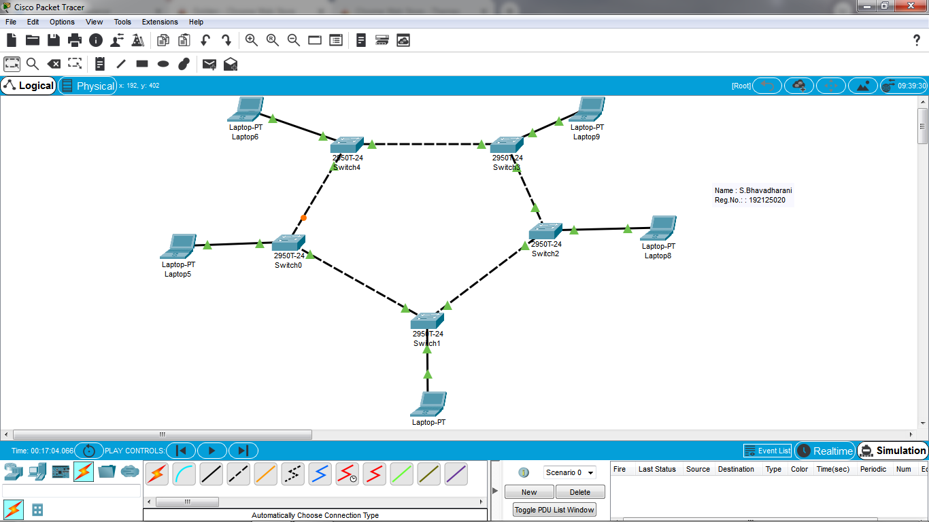

**HYBRID TOPOLOGY:**

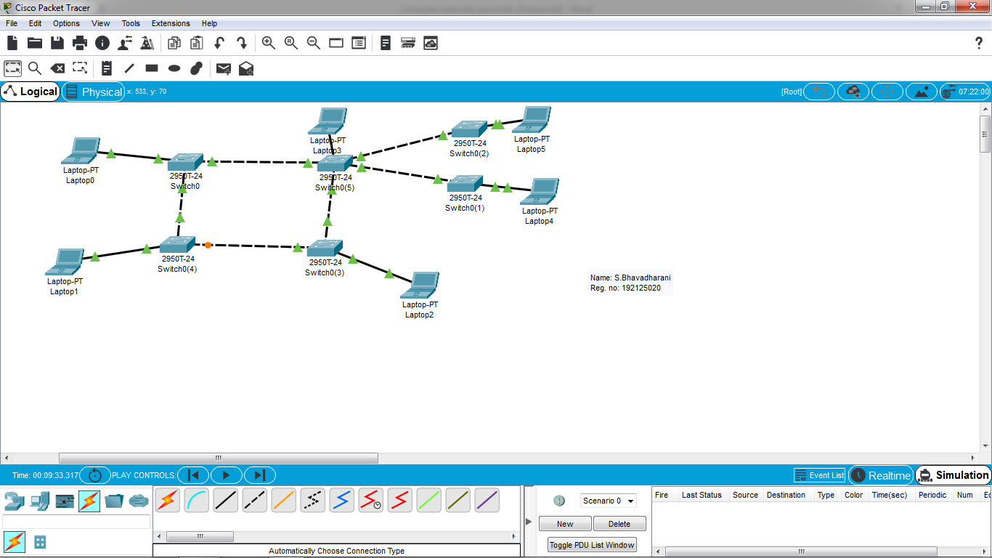

**EXPERIMENT 4: Data Link Layer Traffic Simulation using Packet Tracer Analysis of CSMA/CD& CSMA/CA**

**CSMA**

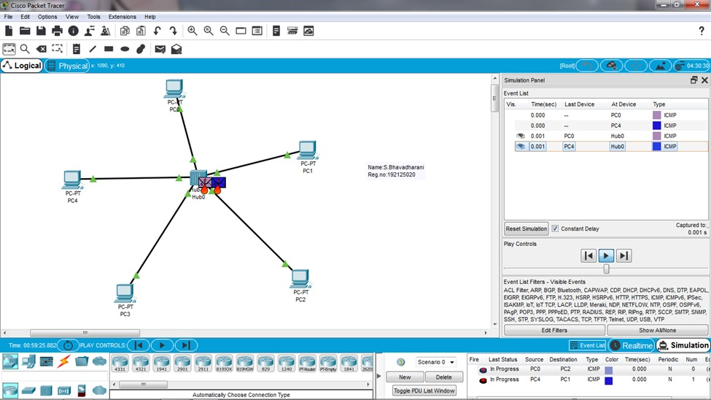

**EXPERIMENT 5: Data Link Layer Traffic Simulation using Packet Tracer Analysis of ARP**

**ARP**

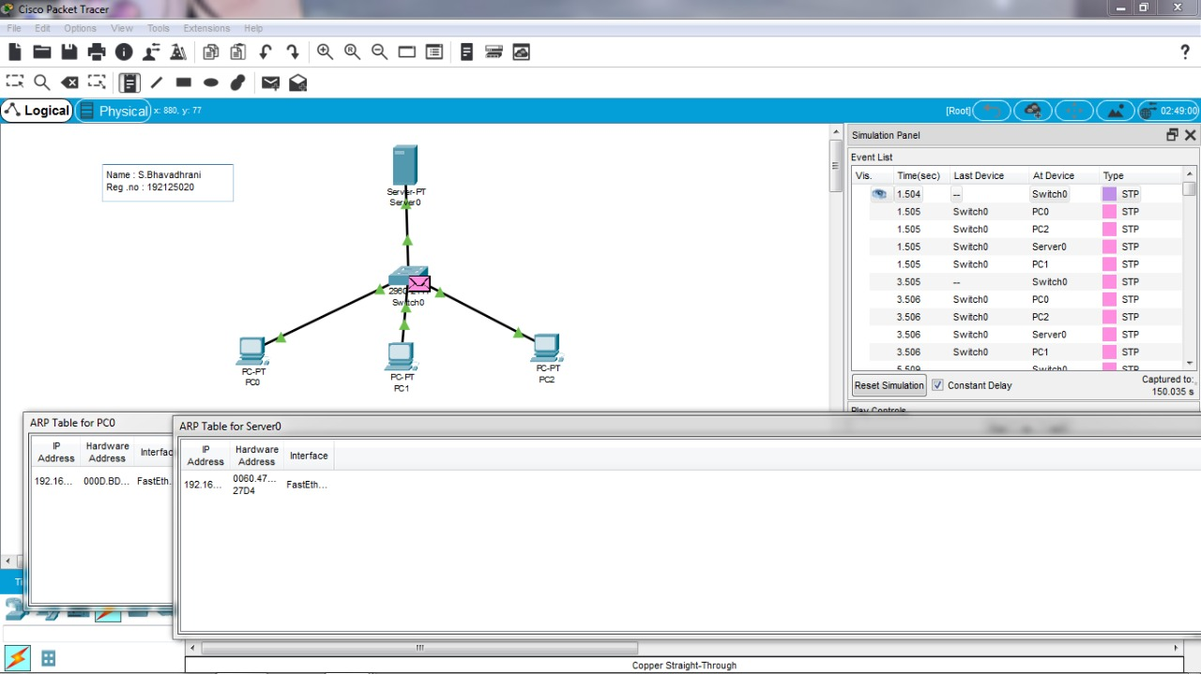

**EXPERIMENT 6: Static Routing using Packet Tracer**

**STATIC ROUTING**

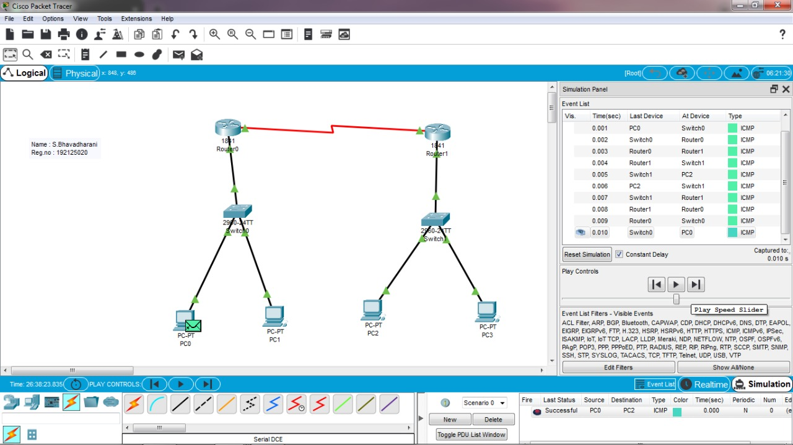

**EXPERIMENT 7: Dynamic Routing using Packet Tracer ( OSPF)**

**DYNAMIC ROUTING**

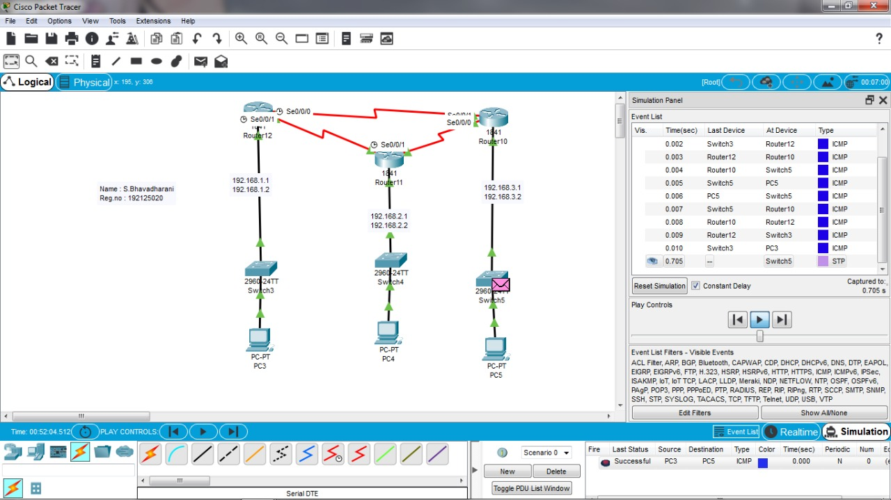

**EXPERIMENT 8: Subnetting – Class C Addressing**

**SUBNETTING – CLASS C**

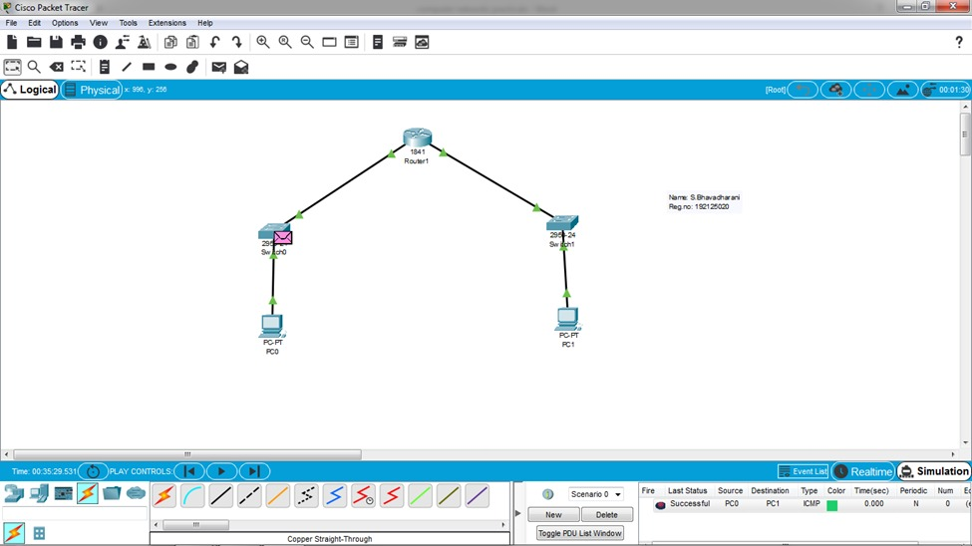

**EXPERIMENT 9: Functionalities of TCP, UDP**

**FUNCTIONALITY OF TCP AND UDP**

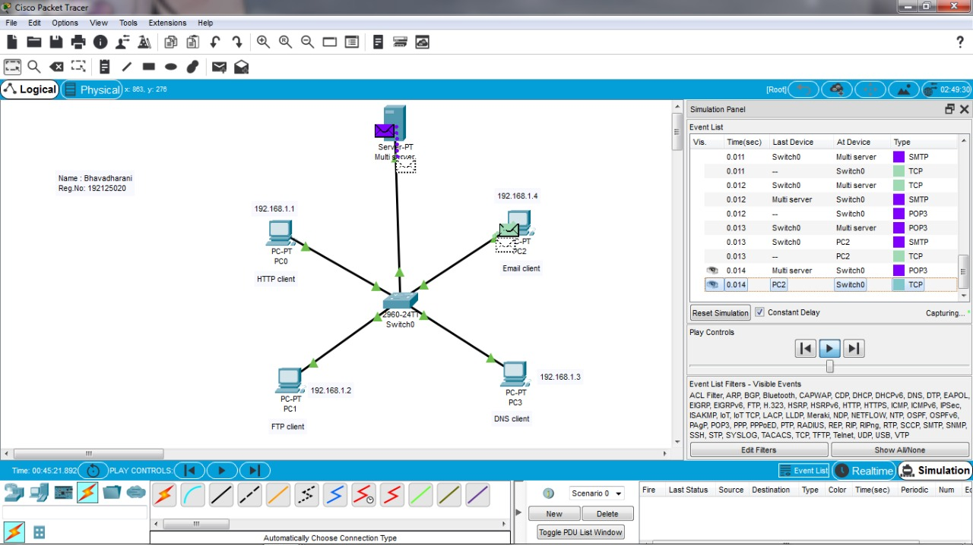

**EXPERIMENT 10: TCP, UDP Exploration Solution**

**TCP UDP EXPLORATION**



**EXPERIMENT 11: IOT Based Smart Home Using Cisco Packet Tracer**

**IOT SMART HOME**

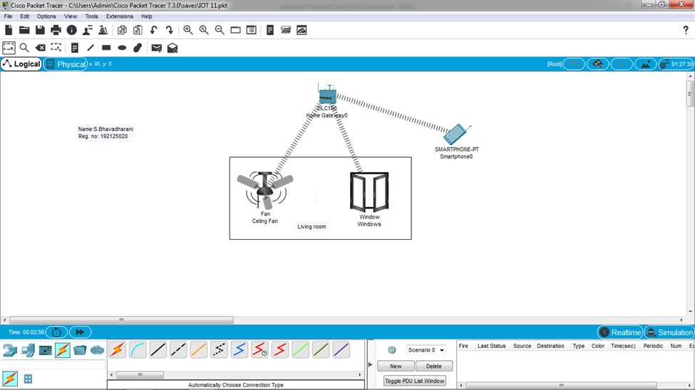

**EXPERIMENT 12: Smart Garden in Cisco Packet Tracer**

**IOT SMART GARDEN**

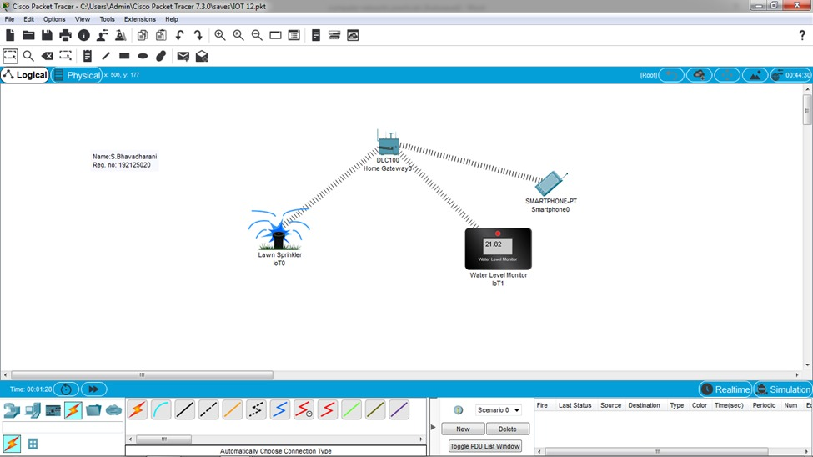

**EXPERIMENT 13: IOT Devices in Networking Using Cisco Packet Tracer**

**IOT SMART HOME USING NETWORKING**

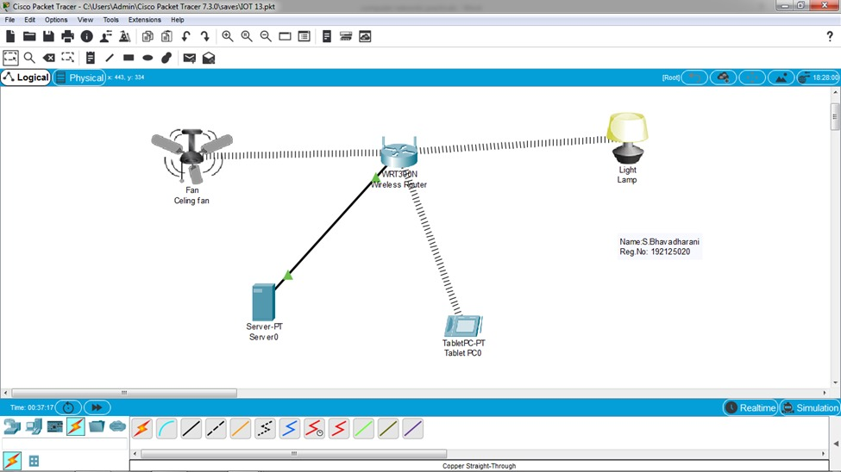

**EXPERIMENT 14: Simulating X,Y,Z Company Network Design**

**SIMULATION OF X,Y,Z**

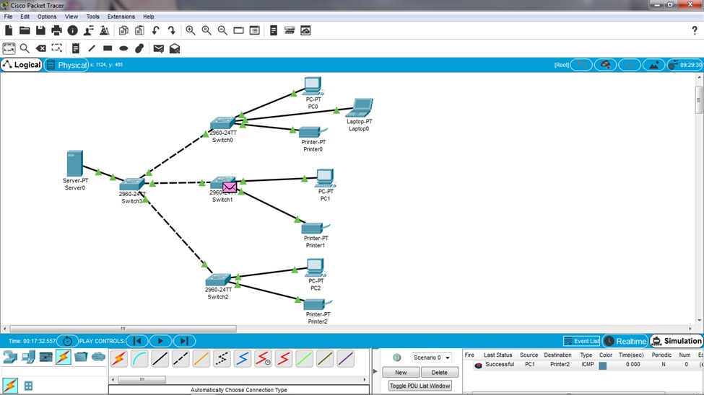

**EXPERIMENT 15: Make Computer Lab in Cisco Packet Tracer**

**COMPUTER LAB**

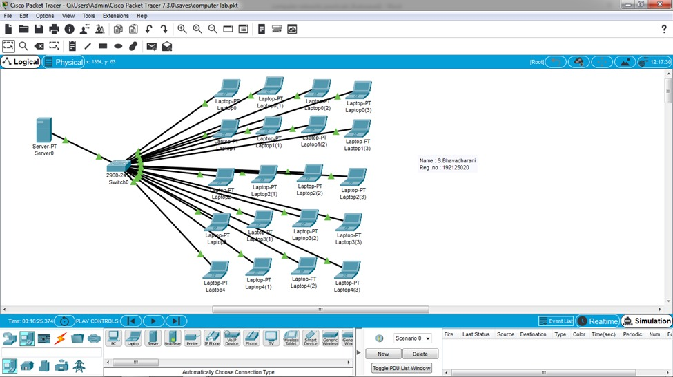

**EXPERIMENT 16: Simulate a Multimedia Network**

**MULTIMEDIA NETWORK**

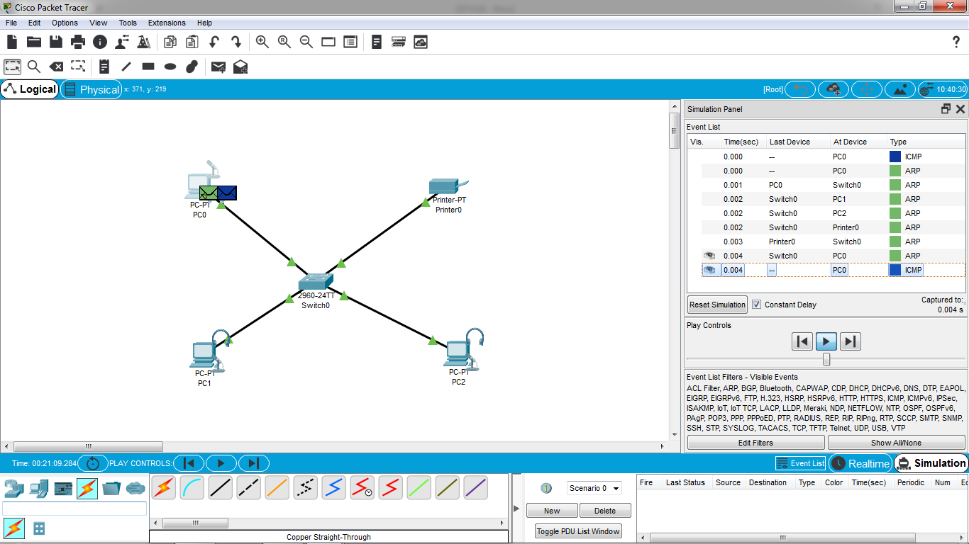

**EXPERIMENT 17: AAA Local & Server Based Authentication Configuration in Cisco Packet Tracer**

**AAA**

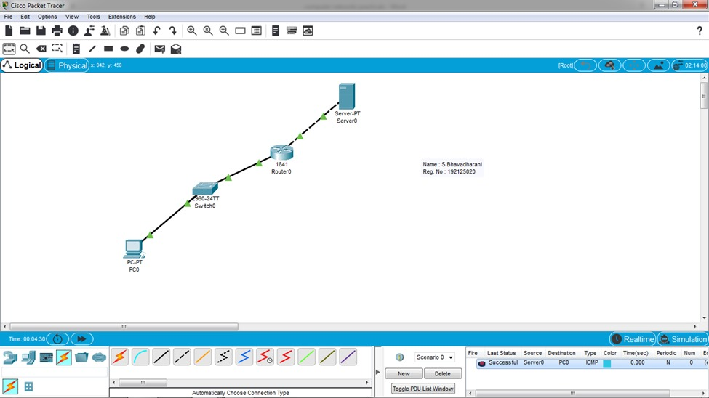

**EXPERIMENT 18: IOT Based Smart Home using WPA Security & Radius Server**

**WPA SECURITY**

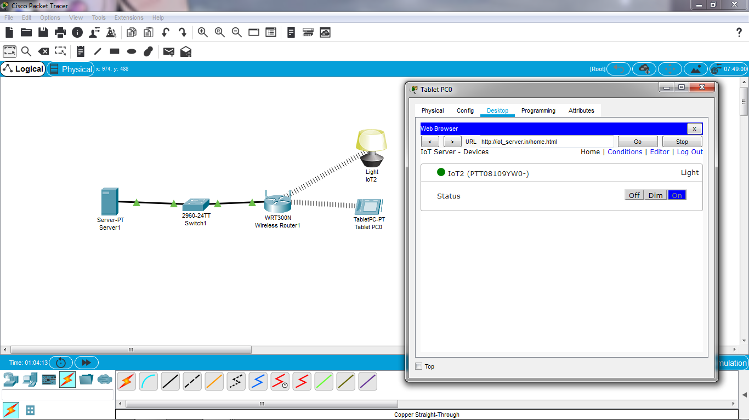

**EXPERIMENT 19: WLAN Using Cisco Packet Tracer**

**WLAN**

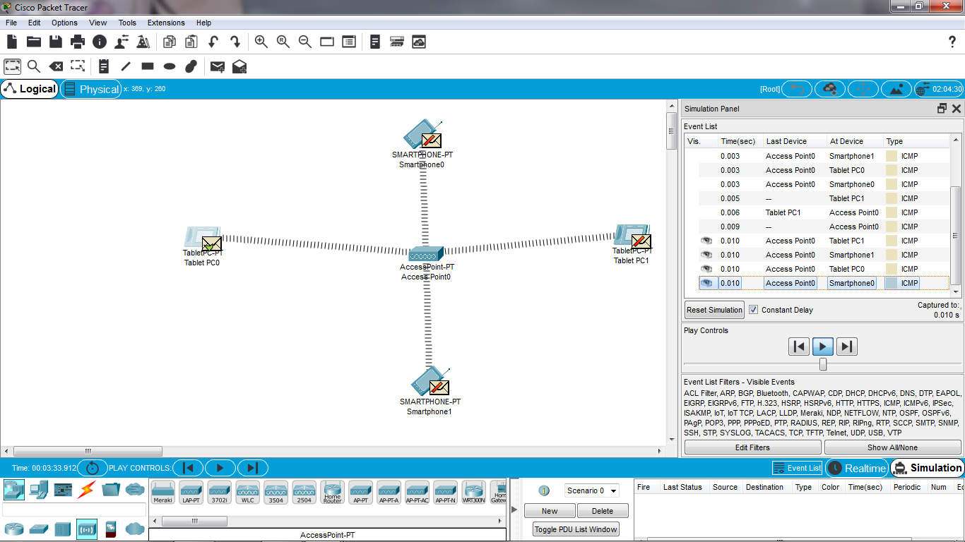

**EXPERIMENT 20: Control of Fan, Light, Window & Application of Using Cisco Packet Tracer**

